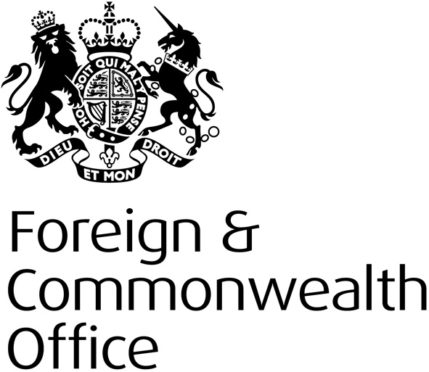

FCO Human Rights and Democracy Programme: Preventing Sexual Violence Initiative funding round 2013/14:

Human Rights and Democracy Department /Preventing Sexual Violence Initiative
July 2013

Programme Overview

Human rights, democracy and the rule of law are at the heart of HMG’s foreign policy. The Human Rights and Democracy Programme (HRDP) is the FCO’s dedicated fund supporting human rights and democracy work overseas. The Programme aims to make a difference to people’s lives, helping to build the capacity of governments and civil society to promote and protect human rights.

Preventing Sexual Violence Initiative

The UK promotes gender equality and tackles violence against women and girls as a matter of principle. The Preventing Sexual Violence Initiative (PSVI) is concerned with the impact sexual violence in conflict can have on prospects for long-term peace and stability. It is framed by and supports the implementation of UN Security Council Resolutions relating to Women Peace and Security. Long-term efforts to address peace and stability involve not only the cessation of violence but also processes of reconciliation, including addressing injustices and crimes carried out in conflict and post-conflict contexts. PSVI’s key objective is to tackle the culture of impunity that exists for crimes of sexual violence, and to replace this culture with one of deterrence. It aims to do so by paying greater attention to holding perpetrators of sexual violence crimes to account, strengthening effective mechanisms and the political will to do so and providing greater levels of physical security and psycho-social support to victims and survivors (women, men, girls and boys). While it is the responsibility of national governments to provide protection for persons within their jurisdiction, there is a strong role for civil society groups to provide practical support to victims and to seek greater accountability.

For more information, please see the G8 Declaration on Preventing Sexual Violence in Conflict adopted in London on 11 April 2013, available here.

Projects funded under this scheme will focus on the work that civil society can do to hold governments to account against commitments made to address sexual violence in conflict. They will also focus on practical protection and prevention approaches that can have a demonstrable and measureable impact. Funding will be made available for civil society organisations and specifically for projects and programmes that address rape and sexual violence in conflict and post-conflict contexts.

Violence against women and girls is a priority for the HRDP. Projects that seek to tackle non-sexual violence in non-conflict situations should not be submitted under this funding round. If you are interested in submitting a proposal in this area please refer to the main HRDP strategy and contact the local embassy or high commission to see if funds are available.
Objective | Target Areas
- To support the work of civil society organisations, including women’s organisations, and human rights defenders and networks to:  - Enhance community-level prevention and protection against sexual violence in conflict and post-conflict environments.  - Help victims and survivors of sexual violence to get better access to justice; and  - Promote greater accountability by national institutions responsible for tackling sexual violence. | Prevention  Initiatives for advocacy and action at the community and national level to tackle sexual violence. Greater women’s - but also men’s - participation and engagement as partners in actions to reduce the likelihood of sexual violence taking place ( for example actions that aim to change attitudes and behaviours and aim to work with state and local institutions – schools, churches, national authorities perhaps)  Initiatives that build grassroots awareness of the issue and how to overcome the challenges in tackling sexual violence in conflict and post-conflict situations (for example, outreach and training for civil society and state actors on legal and other rights)
Protection
Initiatives that enhance the role of those who defend the human rights of women to carry out or support monitoring, fact-finding and documenting cases of sexual violence and empowering victims to access justice.
Accountability
Initiatives that aim to promote greater accountability of national justice and other institutions and bodies through advocacy and action.

Key Guidance

Potential Implementers should read the “Guidance for potential implementers” document before bidding and bids must be made on the bidding form (both available here). The key points are:

Bidding Process
Projects must be submitted via the relevant British embassy or high commission. Implementers must engage with the embassy or high commission in the relevant country/countries to gain their support for the proposal. The HRDP team will not accept proposals submitted directly. The deadline for submitting project proposals to the relevant embassy or high commission is close of business Wednesday 28 August 2013.

Missions will then review and assess proposals locally before submitting supported projects to the Human Rights and Democracy Programme Team in London who will perform an initial assessment. The 30 projects that most closely align with the funding criteria will then be submitted to the Human Rights and Democracy Programme Board - which comprises human rights and project experts for full assessment. It is our aim to inform all successful and unsuccessful projects by the first week of October 2013. Project that do not follow the bidding guidance will be rejected.

Selection Criteria
Projects must deliver outputs and outcomes relevant to the PSVI criteria. Projects that clearly demonstrate how they will address the target areas will improve their chance of support. Bids will also be assessed against the following criteria:

- Value for money
- Evidence of local demand/need
- Project viability, including capacity of implementing organisation(s)
- Project design, including clear, achievable objectives/outputs
- Sustainability
- Good risk and stakeholder management

Projects should be realistic in the results they aim to deliver and how these contribute to the long term achievement of the targets. Proposals must be supported by a realistic activity-based budget, set out with as much detail as possible. This is a key requirement in evaluating the project proposal. Lack of a detailed budget was among the top reasons why projects were rejected in 2012.

Projects
Projects should begin from November 2013 and must be completed by end February 2015. Projects that are due to conclude by March 2013 will be eligible for funding up to £200,000; projects that run into April 2014 and beyond are eligible for funding of up to £400,000. All projects must be in Official Development Assistance eligible countries. Please see the OECD website for a list of ODA eligible countries. We welcome projects jointly funded with other donors as a way of increasing impact and enhancing co-ordination. All projects must demonstrate how they complement the efforts of other donors and bring added value. We strongly encourage projects that seek to secure future funding from other bodies (e.g. EU, UN) for follow-on work.

Key Contacts
HRDP Team - All general queries relating to the programme.

Contact details for our Embassies, High Commissions and Missions can be found at:
https://www.gov.uk/government/world/organisations

